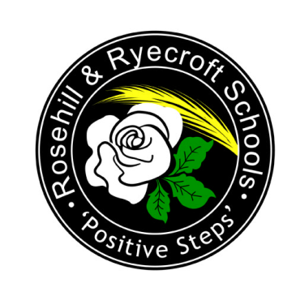
Rawmarsh Ryecroft Infant School

Sports Premium Information 2019 – 2020

Financial Year Amount of Sports Premium Funding
2019 – 2020 £17,170

What is it and how are we spending it?
The Sport Premium is an amount of money which is allocated to schools by the government in order to improve the quality of sport and PE for all their children. It is also for improving the health and wellbeing of primary children. The amount of funding that school receives is based on the number of children of primary age in that school. The money can only be spent on sport and PE provision in schools such as hiring sports coaches to work with the teacher.

The funding is to be extended to 2020, which will allow us to continue to develop sports provision within school and to help us increase children’s participation in sporting activities.

Sports Premium Funding 2019/2020
The total Sports Premium funding for the school year 2019/2020 was £17,170. The funding was provided in 2 separate payments, one in December 2019 and another in April 2020.

School’s Allocation at December 2018 | £10,016
School’s Allocation at April 2019 | £7,174
Total | £17,170

Proposed expenditure
Ryecroft Infant School is committed to ensuring that the sports premium is used to increase the quality and breadth of PE and sport provision. We want to increase the participation in PE and promote healthy and active lifestyles. It is for schools to decide how the Sports Premium is spent and we are dedicated to making sure that this is spent effectively.

The planned spending for the academic year 2019-20 is as shown below. This has been decided following the successful plan that has been in place for several years. There may be some slight changes if necessary.

PE and Sports Premium Spending

Hiring specialist sport coaches for PE and After School Clubs | £6,280 (Active Fusion)
Sports Specific SMSA for lunchtime | £988
Purchase of additional resources to support physical skills development in EYFS. | £2000
Outdoor Resources | £4900 (approx.)
Hire of EIS (June 2019) | £795 + Deposit for next year of £200
Transport to EIS (June 2019) | £750 (approx.)
Resources for Movement Evening | £60 (approx.)
Purchase of additional / new PE equipment to enhance current provision | £400
Staff costs for attendance at courses / training. | £800
Total Resources spending 2019-20 | £17,173 (£3 over allocation)

What is the Impact of the Sports Premium Grant?

Sports Premium Grant has led to:
- Increased teacher’s subject knowledge by observing a range of different sporting activities.
- Increased opportunities for all of our pupils to access a wider variety of PE and Sports including dance.
- Increased opportunities to develop the competitive element of sports and the skills of sportsmanship.
- Children having developed an increased understanding of the importance of keeping fit and healthy and ways that they can improve their health and fitness.
- Children being more motivated to participate in PE.
- Children being more motivated to improve to become fitter and healthier.

The funding is to be allocated to continue to extend and develop this work.

